CS415 HW2 Report

Xichen Liu

The output images:

Kernel size = 3

Strong edge ratio : Weak edge ratio = 0.3 : 0.1:

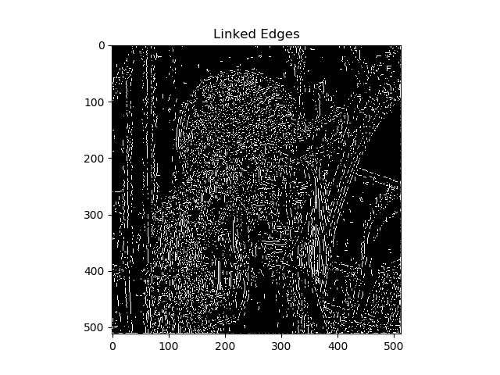

Kernel size = 3

Strong edge ratio : Weak edge ratio = 0.03 : 0.01:

Kernel size = 6

Strong edge ratio : Weak edge ratio = 0.3 : 0.1:

Kernel size = 6

Strong edge ratio : Weak edge ratio = 0.03 : 0.01:

Here is the process to get the result:

1.Gaussian Smoothing: Apply Gaussian blur to the image

2.Calculating Image Gradient: Use Sobel operator to get the (df/dx) and (df/dy), then compute the gradient magnitude and gradient direction by applying the formula

3.Suppressing Nonmaxima: This step is to find the local maxima, and as for other non-local-maxima points, lower them to 0.

4.Thresholding and Edge Linking: separate the points into three groups: strong edges, weak edges, and zero edges. And then link the strong edges by the weak edges.

From the outputs, I assume that if the Gaussian filter kernel is getting larger, the final output will be less detailed. I think it’s because that the smoothing will wipe the edges.

And if the actual value of the thresholds is smaller, there will be so much more noise on the output. My thinking is that the thresholds is to low, so it’s not like a threshold. It allow too many edges to pass the threshold.